IT24101067

Dissanayake D.M.K.K.

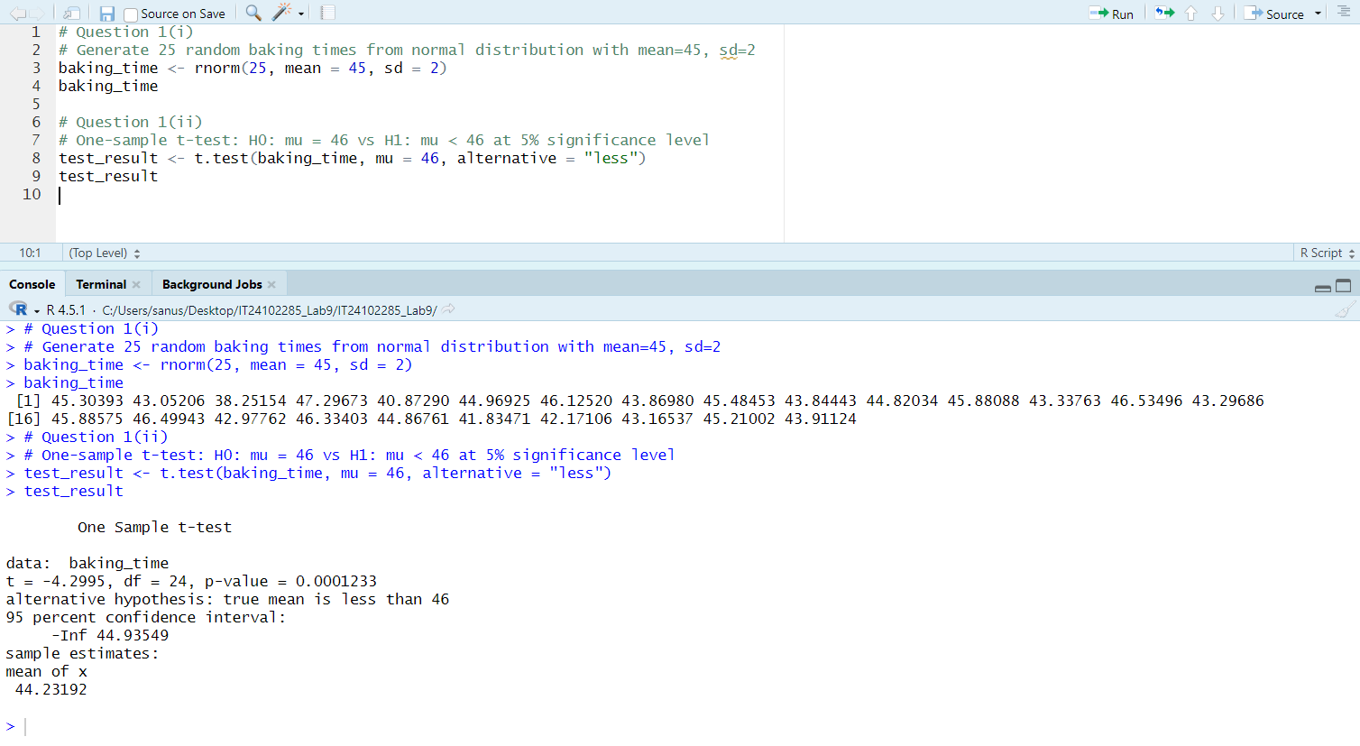Lab 09